Newsletter – June 2023

St John’s House in June

The plant sale at the end of May went really well so thanks to all of you who came along and bought plants. We still have some a few spider plants and sempervivums left in our shop.
We will be holding the June Quiz in aid of funds for St John’s House in the outdoor bowls club in Newbridge Fields on June 16th.
We are open on Sunday 11th June with a new animal trail for children as well as our usual toys and brass rubbing.
Our Saturday Open Day on June 24th falls on St John’s Day so it seemed like the perfect opportunity to look back at what we’ve achieved and look forward to the future – more about that on the day!
The Mayor of Bridgend is coming along to join in the celebrations and we have commissioned the poet Phil Knight to write a poem for the occasion which he will perform on the day. and we are planning to offer afternoon tea.
With all this activity, we have decided to defer the historical walk for a future open day.
Come along and celebrate summer with us here at St John’s House.
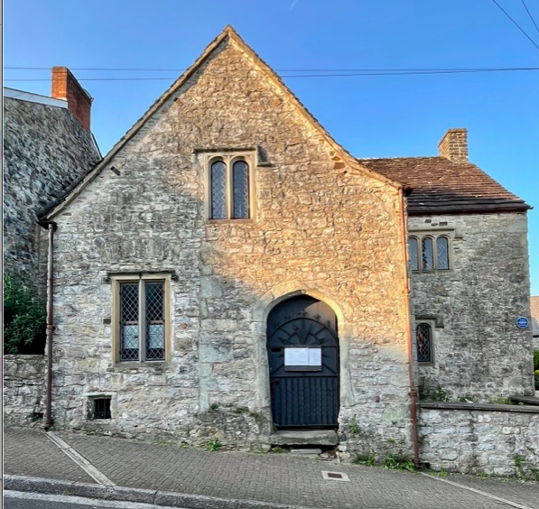

Dates for your diary

Next open day Sunday 11th June 2023 11am-3pm
Saturday 24th June 2023 11am-3pm
Sunday 9th July 2023 11am-3pm
Saturday 29th July 2023 11am-3pm

Next two quiz dates Friday 16th Jun 2023 7.30pm
Friday 21st July 2023 7.30pm

St John’s Day

We have two St John’s to choose from, both very significant Christian saints so we thought we would hedge our bets and include them both.

Whichever St John you may favour, come along and celebrate him with us in our end of June open day.

St John the Baptist, whose saint’s day is celebrated on June 24th, was an itinerant preacher in the wilderness of Judea. He preached the coming of the Messiah and baptized people in the River Jordan as a symbolic washing away of their sins. He was related to Jesus through their mothers and indeed baptized Jesus, for which he is often known as John the Forerunner.
He criticized King Herod and his repudiation of his first wife in favour of Herodias, who famously sought deadly revenge. Her daughter Salome had danced at her mother’s wedding to King Herod and Herod was said to be so delighted that he offered Salome anything she wished. Prompted by her mother, she asked for John’s head. Herod had already been concerned at the size of John’s following so readily agreed. Unfortunately the story of the rather steamy dance of the seven veils stems from Herod’s evident appreciation of her dancing, rather than through any actual evidence.

St John the Evangelist has a direct connection to St John’s House as we have the carved stone block in the hallway showing the Eagle associated with this St John as well as a croix pattée type cross. Traditionally he is regarded as the author of the fourth gospel, the last of the four to be written but it is probable that it was written much later based on the stories of St John the Apostle. Whereas the narratives of the first three gospels largely agree, hence they are known as the Synoptic Gospels, that of St John relates different aspects of the life of Jesus and follows a different timeframe. Its character is more theological and, for that reason, it had a greater impact on the teaching and beliefs of the early Christian church.

Don’t forget to have a look in our gift shop and secondhand book shop as we have all sorts of lovely items for sale.
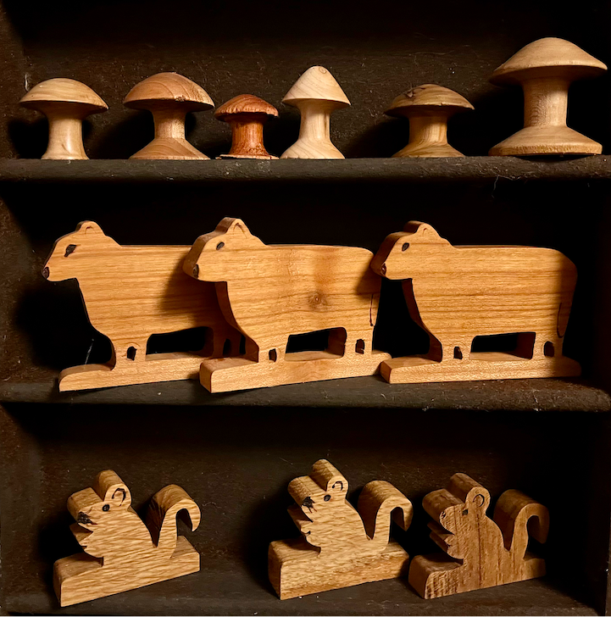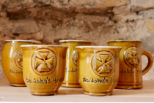

St John’s House is a charity, our charity number is 1147340
Email: saintjohns@hotmail.co.uk
Website: https://stjohns-bridgend.org.uk
Facebook: St John’s House Bridgend
Address: 22 Newcastle Hill, Bridgend, CF31 4EY

