Newsletter – July 2023

We’ve done it!
Thanks to your continued support we have been successful in buying St John’s House.

Now that St John’s House Trust owns St John’s House, the trustees, committee members and volunteers aim to forge ahead with improvements to place this historic building at the heart of our community serving Bridgend and surrounding areas.

To achieve this we need your help.
Owning the House will more than double our essentail annual operating and maintenace costs. A donation of £3 a month towards these costs would enable the St John’s House Trust to maintain and improve the building for the benefit of Bridgend.

Your regular donation would play a vital role in enabling the Trust to:
- Conserve this Grade ll* listed building for future generations
- Cover the essential running costs
- Make St John’s House an outstanding heritage attraction for Bridgend
- Share the knowledge of St John’s House and its place in local history
- Offer attractive spaces for community use
- Play a vital role in the regeneration of Bridgend

For details of how to donate, please see overleaf

Dates for your diary

Next open day Sunday 9th July 2023 11am-3pm
Saturday 29th July 2023 11am-3pm
Sunday 13th August 2023 11am-3pm
Saturday 26th August 2023 11am-3pm

Next two quiz dates Friday 21st July 2023 7.30pm
Friday 18th August 2023 7.30pm
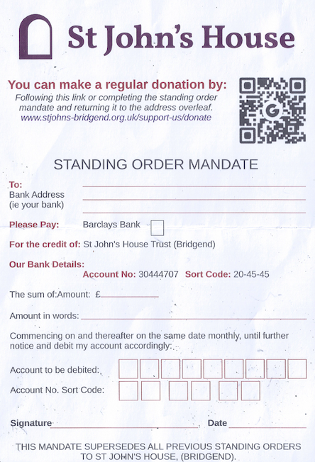

St John’s House is a charity, our charity number is 1147340
Email: saintjohns@hotmail.co.uk
Website: https://stjohns-bridgend.org.uk
Facebook: St John’s House Bridgend
Address: 22 Newcastle Hill, Bridgend, CF31 4EY

