

**Newsletter** – September 2024

**St John’s House in September**

Summer is over, the children are going back to school and it’s time to start thinking about planting bulbs for next Spring!

We still have our Mapping Bridgend display in our exhibition space and we’ve tidied up the Georgian kitchen so if you haven’t been here for a while, it’s worth popping along to see what’s changed.

As it’s September it’s Cadw’s Open Doors festival so we will be open for an extra day on September 29th to celebrate.

This month we are excited to be a part of the very first Ogwr History Month organised by the Awen Culural Trust and involving heritage organisations across Bridgend County. As part of that celebration we have Debra John coming along in her role as a Victorian parlourmaid on Sunday the 8th and the medieval archers with their fascinating equipment and encyclopedic knowledge will be in St John’s House on Saturday and Sunday,the 28th and 29th.  In addition to the house itself there’s plenty for history buffs this month!

The quiz in September is a week earlier than usual as the Outdoor Bowls Club are away on tour on our normail third Friday so it’s being held the week before.

In October Debra John is back with an evening of ghostly tales and, towards Christmas we are going to be running some Christmas wreath-making workshops and a series of candlelit tours of the house.

**Dates for your diary**

**Next open days** Sunday 8th September 2024 11am-3pm

Saturday 28th September 2024 11am-3pm

Sunday 29th September 2024 11am-3pm

Sunday 13th October 2024 11am–3pm

Saturday 26th October 2024 11am-3pm

**Next two quiz dates** Friday 13th September 2024 7.30pm

Friday 18th October 2024 7.30pm

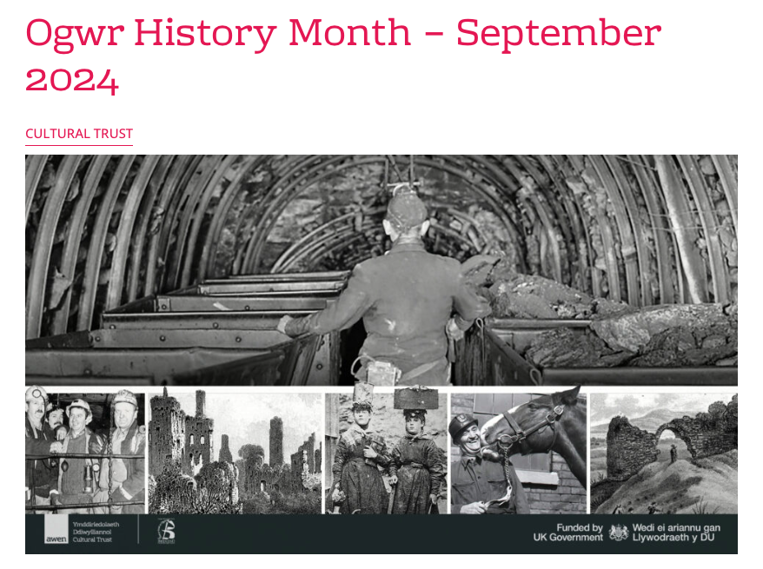

September brings a month of free history activities as part of the inaugural Ogwr History Month. Throughout the month there will be free history talks, walks and displays across Bridgend County Borough.

Ogwr History Month is organised by the Ogwr Heritage Network, a partnership of history societies and heritage sites across Bridgend County Borough.

Stefanie van Stokkom, Heritage Manager at Awen Cultural Trust explains. “There is so much history around Bridgend County Borough, from prehistoric sites to medieval castles and industrial valleys. We tend to overlook the history around us, so the History Month is a great way to find out more about history on our doorteps as well as further afield. It also provides a great opportunity to support local heritage sites and get involved in our brilliant local history societies.”

Thanks to UK Government funding, all Ogwr History Month activities are free. This includes talks by the likes of Will Millard and Martin Johnes, as well as history walks by Graham Loveluck Edwards. There are also a variety of open days and exhibitions, including a display on the 40th anniversary of the Miners’ Strike which includes a virtual reality experience.

The link to the full programme is here:

Our shop has all sorts of traditional gifts and mementos of St John’s House including love spoons, postcards, cute small crocheted potted plants and our own range of stationery to remember us by. We also have an extensive seletion of secondhand books for sale so why not pop in and see what we have on offer.

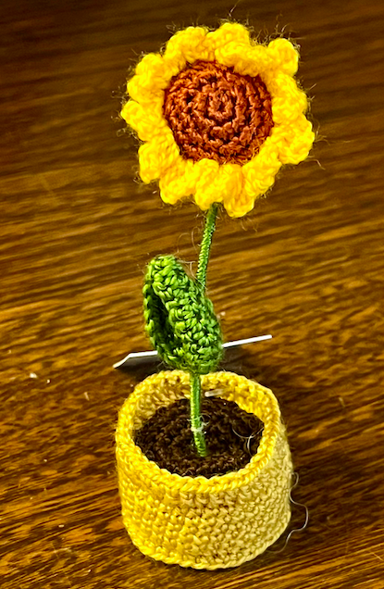 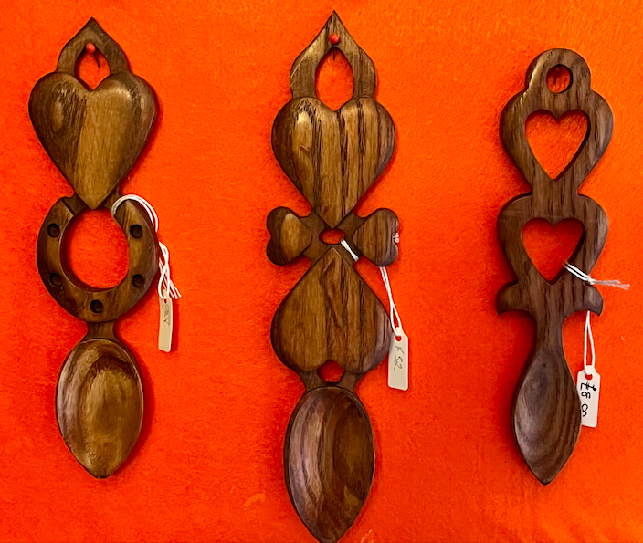 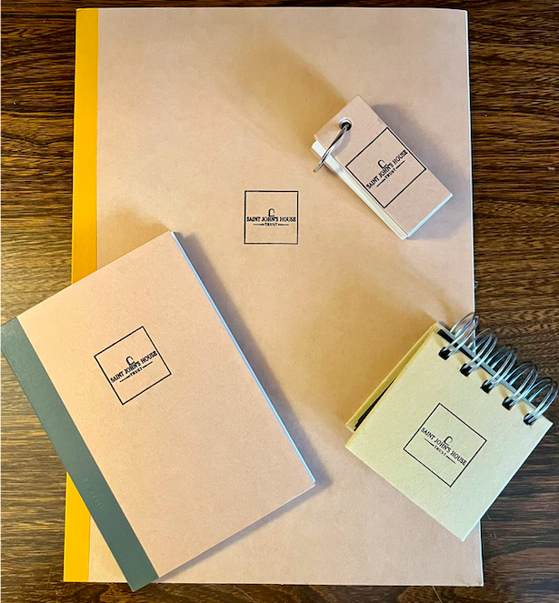

St John’s House is a charity, our charity number is 1147340

Email: [saintjohns@hotmail.co.uk](mailto:saintjohns@hotmail.co.uk)

Website: <https://stjohns-bridgend.org.uk>

Facebook: St John’s House Bridgend

Address: 22 Newcastle Hill, Bridgend, CF31 4EY