Newsletter September 2023

St John’s House in September

September at St John’s House always means Cadw’s Open Doors. We are just one of the many public buildings celebrating our heritage this month.

On September 30th we are looking forward to welcoming back our friends the archers from the Freemen of Gwent as well as Wildcall, the musicians who have played here before. It promises to be a great day and we’ll be open for an extra hour on the September open days so nobody misses out.
Bread Oven Excavation
Here are some pictures for those who haven’t been able to get to the house. Left is the excavated oven and Right is the view of the carefully numbered stones which were removed.
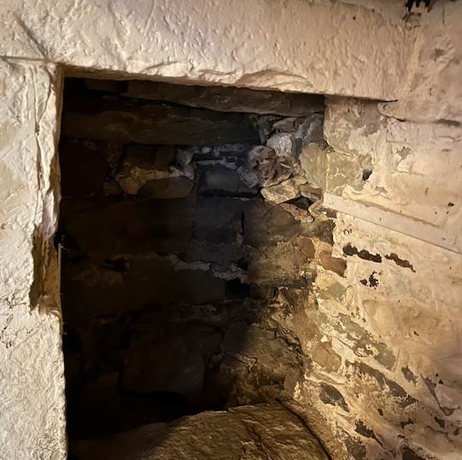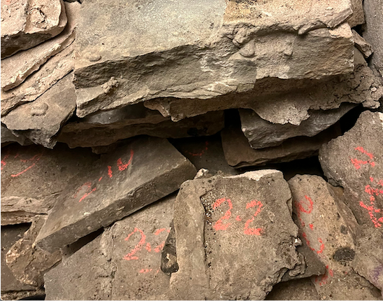

We are pleased to report that we have had a steady response to our ongoing support scheme designed to ensure that everyone has the chance to help maintain and improve the building for the benefit of Bridgend.
For details of how to donate, please see click here

Dates for your diary

Next open day Sunday 10th September 2023 11am-4pm Saturday 30th September 2023 11am-4pm
Sunday 8th October 2023 11am-3pm Saturday 28th October 2023 11am-3pm

Next two quiz dates Friday 15th September 2023 7.30pm
Friday 20th October 2023 7.30pm
Harvest Festival

September is the time of year when traditionally we celebrate the harvest. It’s also the time of the autumn equinox when the sun is directly above the equator, making day and night equal in length and starting the long slow descent into winter. This year’s autumn equinox falls on September 23rd

Harvest festivals are a reminder of Britain’s rural past when whole communities helped to bring in the grain indeed the origin of the long school summer holiday was to allow children to be used to help with the harvest.

There are many rural traditions associated with the completion of the harvest including feasting and drinking. Corn dollies were made from the last sheaves of corn cut and these were meant to appease the spirit of the corn and ensure a good harvest the following year.

By tradition, the harvest was finished by Michaelmas day – the feast of St Michael, the Archangel - and, following on from the autumn equinox, it is also a quarter day, when, in the past, rents were due, casual labourers were re-hired, school terms began and a new season was celebrated.

Our shop has had a new delivery of Tudor-style hand-made notebooks, unique to St John’s House.
These are created just for us by the craft bookbinders, Colville & Gibbs and we think that they would make great presents

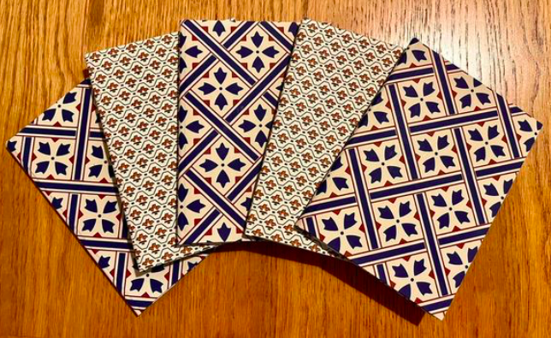

St John’s House is a charity, our charity number is 1147340
Email: saintjohns@hotmail.co.uk
Website: https://stjohns-bridgend.org.uk
Facebook: St John’s House Bridgend
Address: 22 Newcastle Hill, Bridgend, CF31 4EY

