

**Newsletter** – October 2024

**St John’s House in October**

The first Ogwr History Month is now over and it’s been a busy one. We had an extra open day and events in St John’s House. We enjoyed welcoming Graham Loveluck Edwards and all the people who joined him on his history walk around Bridgend and were facinated by Phil Cope’s talk on Holy Wells of Wales with some riveting pictures to accompany the talk. We were lucky to have Debra John as a Victorian parlourmaid on one open day and the medieval archers with their equipmnt and their encyclopedic knowledge of the Middle Ages on the other open days. Thanks go to the Awen Cultural Trust for sponsoring them and indeed for masterminding Ogwr History Month.

On our October open days, in St John’s House’s Georgian kitchen, our resident artist, Tim Lewis, will again be hosting his Georgian tea making experience – *Take Tea with Walter Coffin*. We are also excited to welcome back Contraband. They specialise in medieval music from around the world and have been based in Wales for almost 20 years. They feature a wide variety of instruments providing some of the best music blended in a unique, improvisatory style

Debra John’s evening of ghostly tales at the end of the month has sold out, as have our wreath making sessions, but we stil have tickets for the candlelight tour on December 10th at 7pm – only £6 per person.

The quiz in October is back to its third Friday slot at the Outdoor Bowls Club.

**Dates for your diary**

**Next open days** Sunday 13th October 2024 11am-3pm

Saturday 26th October 2024 11am-3pm

Sunday 10th November 2024 11am–3pm

Saturday 30th November 2024 11am-3pm

**Next two quiz dates** Friday 18th September 2024 7.30pm

Friday 15th November 2024 7.30pm

**Walter Coffin**

We have not been able to find any records of the early years of St John’s House but we know that in the late 1770s it was occupied by Walter Coffin. He was born in Selworthy, Somerset, in 1731. His father, also called Walter, was a rich gentleman who, through unwise speculation, managed to lose his wealth. His widow moved with her younger son, Walter, to Bridgend as she was the half-sister of Dr Richard Price, of Llangeinor, the philosopher. Unlike his father Walter was industrious and established a tannery on the banks of the Ogmore across from where the multistory car park now stands at the foot of the Rhiw. He lived, in the late 1770s, here in St John’s House. He was said to be reserved, retiring and somewhat parsimonious. His business thrived and he built up a substantial holding of land in South Wales. In 1782, at the age of 51 he married his cousin Anne Morgan, 20 years younger. She had been in London keeping house for her brother, William Morgan. The couple moved to a large house, now demolished, across the river at Nolton, where they had three children. Walter died in 1812, aged 81. His son, again also called Walter (the Coffins were not exactly adventurous in naming their children!) went on to make his fortune through coal mining, though that’s for a future instalment.

As an aside, our exhibition of maps – *Mapping Bridgend* – includes the map Charles Edwin had drawn up when he inherited the Dunraven estate in 1778 and ‘Mr. Coffin’s tanyard’ is clearly marked on the map. Pop in and see for yourself!

Our shop has all sorts of traditional gifts and mementos of St John’s House including love spoons, postcards, wooden toys, cute small crocheted potted plants and our own range of stationery to remember us by. We also have an extensive seletion of secondhand books for sale so why not pop in and see what we have on offer.

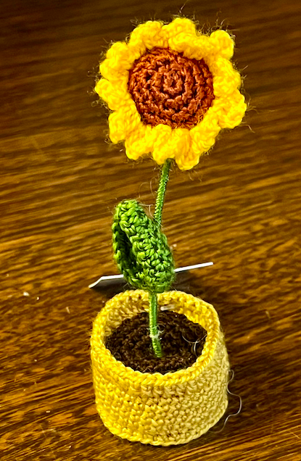 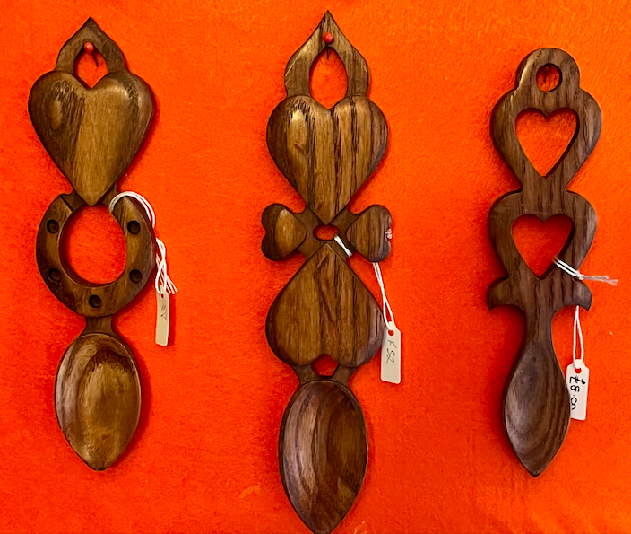 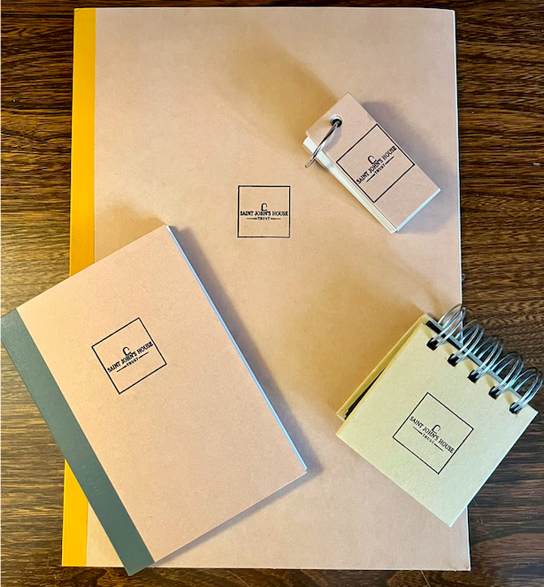

St John’s House is a charity, our charity number is 1147340

Email: [saintjohns@hotmail.co.uk](mailto:saintjohns@hotmail.co.uk)

Website: <https://stjohns-bridgend.org.uk>

Facebook: St John’s House Bridgend

Address: 22 Newcastle Hill, Bridgend, CF31 4EY