Newsletter November 2023

St John’s House in November

Well, Hallowe’en is over and we all enjoyed David Ambrose’s story-telling in the atmospheric setting of St John’s House, complete with Wendy’s special soul-cakes and all those present did their share of soul-saving by eating plenty! It was wonderful to see the great hall full of people in rapt attention at a master of his craft.

Our Sunday open day in November falls on Remembrance Sunday so we will be paying tribute to all those who gave their lives for all of us. We will open at 10:45 in order that we can take part in the two minute silence at 11am.

Christmas at St John’s

After Remembrance Sunday we are into our series of Christmas openings when we spruce up and decorate the house. We will have a Christmas themed trail for children and plenty of seasonal cheer.

Looking ahead to Christmas here at St John’s House as well as decorating the house, we are putting on a special Christmas event on the evening of Friday December 1st. The talented local actress, Debra John, will be giving us an insight into the Victorian Christmas, in the character of a Victorian lady sharing with us her her own experience of Christmas. Tickets are on sale now, they can be booked through Eventbrite. It promises to be a splendid evening.

Dates for your diary

Next open days Sunday 12th November 2023 10:45am-3pm Saturday 25th November 2023 11am-3pm
Saturday 2nd December 2023 11am-3pm
Sunday 10th December 2023 11am-3pm

Next two quiz dates Friday 17th November 2023 7.30pm
Friday 15th December 2023 7.30pm

Lovespoons

The traditional Welsh lovespoon dates back to the 17th century when a young man would give one to his intended both as a sign of his love but also as a demonstration of his skill as a craftsman who would be able to provide for her. The symbols carved into a spoon have meaning – obviously a heart for love, a horseshoe for luck, a key for security, a bell for a wedding.

We now have some very nice lovespoons in the shop, carved in hardwood here in Wales and we have a selection of designs including some rather cute lovespoon keyrings.

We also have our usual selection of items such as smart notebooks and unique St John’s House mugs and beakers so pop along and see what is in our newly-revamped shop.

Local Artist

As part of of our supporting local artists programme we have an exciting installation by local artist, Timothy Lewis. His latest art work Watching Paint Dry (Act 4) will be with us for the next few months and he is eager for people to make their own artistic contribution to the work so come in, pick up a brush and make his day!

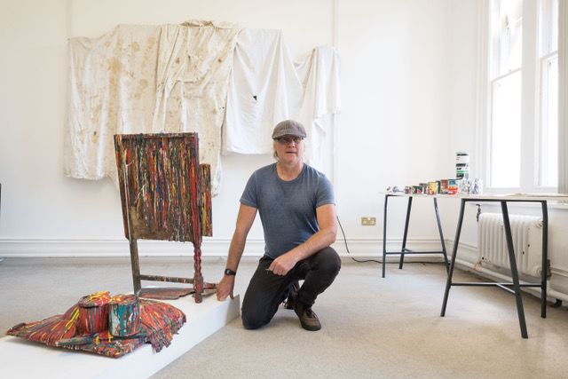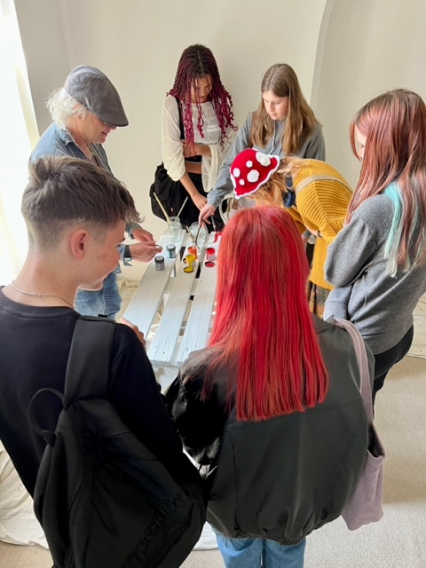

We run an ongoing support scheme to raise funds in order to maintain and improve St John’s House, for details, please click here:

St John’s House is a charity, our charity number is 1147340
Email: saintjohns@hotmail.co.uk
Website: https://stjohns-bridgend.org.uk
Facebook: St John’s House Bridgend
Address: 22 Newcastle Hill, Bridgend, CF31 4EY

