

**Newsletter** – November 2024

**St John’s House in November**

October went well with Contraband coming along with their medieval instruments to bring the house alive with period music and Debra John with her evening of ghostly tales in the atmospheric setting of the Great Hall of St John’s House.

For our next open day on 10/11, Remembrance Sunday, the house will have a more serious feel as we remember those who gave their lives for our freedom.

That will also be the last chance to see our current exhibition – *Mapping Bridgend*.

Then for the Saturday open day on 30/11 we will embrace the start of Christmas. Our new exhibition will, appropriately, feature Nativity scenes. Our wreath making session and our candlelight tour evenings have already sold out but.

We will be talking to the outdoor bowls club about the date of the December quiz as they have a programme of Christmas events, but we will let you know the date in good time!

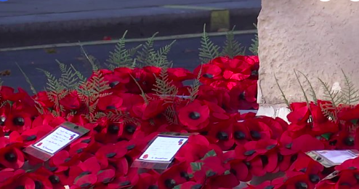

**Dates for your diary**

**Next open days** Sunday 10th November 2024 11am–3pm

Saturday 30th November 2024 11am-3pm

Sunday 8th December 2024 11am-3pm

Saturday 14th December 2024 11am-3pm

**Next two quiz dates** Friday 15th November 2024 7.30pm

December to be confirmed

**Walter Coffin 3**

In the last newsletter we featured Walter Coffin the second, who lived in St John’s House in the late 1770s. His younger son, named Walter Coffin like his father and grandfather, was born in 1784. By this time his parents were living across the river in Nolton. When his father died in 1812 he moved with his mother and sisters to Cardiff. He had tired of the tannery business set up by his father and set about prospecting for coal on farmland which he had inherited in the Rhondda valley.

He estabished a very productive mine at Dinas, producing what became known as ‘Coffin’s Coal’, together with housing and facilities for his workers. He called this new settlement Williamstown after his cousins the Williams family. (Caroline Elizabeth Williams has a blueplaque to commemorate her a few houses further down Newcastle Hill from St John’s House.)

Having built up his mine he set about finding amarket for his coal because transport links were poor and the need locally for coal was more than adequately met. He first collaborated with other mine owners to use the canal system and then became involved with the promotion of the Taff Vale Railway, which opened in 1841 and of which he was a director and later chairman.

In 1852 he retired from business and stood, successfully, as Liberal MP for Cardiff. He didn’t stand for re-election in 1857 and bought a large house in London near Kensington Palace. He died in 1867, leaving his considerable fortune to his Williams cousins, Caroline Elizabeth Williams and her 8 siblings, and, as he and his siblings never married, the Coffin name died with him

*Our shop has all sorts of traditional gifts and mementos of St John’s House including love spoons, wooden toys, jewellery and our own range of stationery. We also have an extensive selection of secondhand books for sale so why not pop in and fill your bookshelves!*

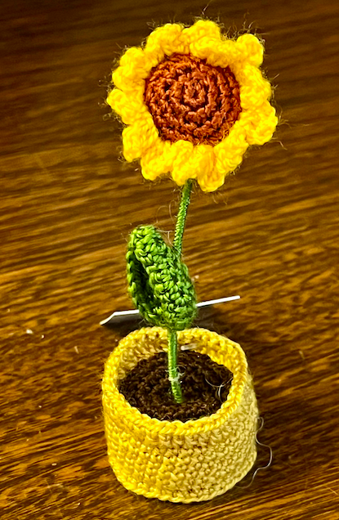 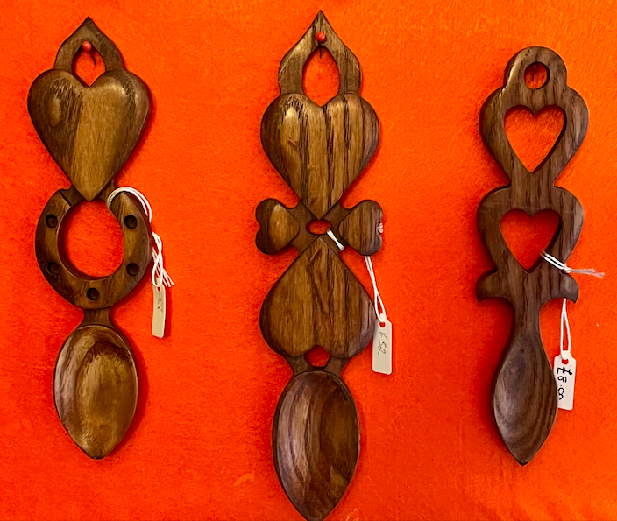 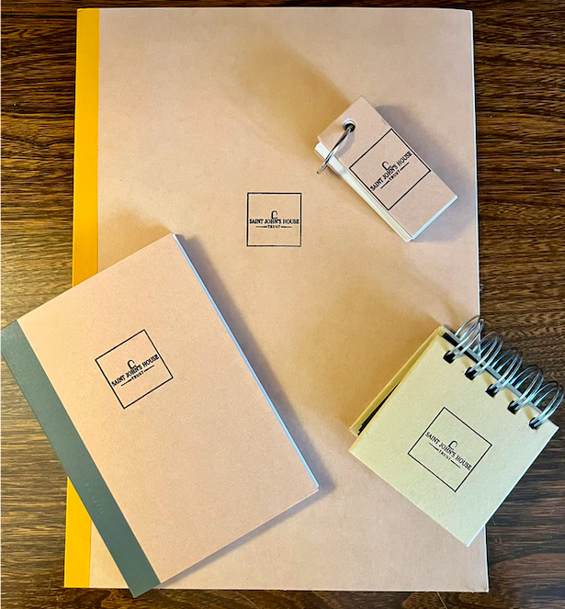

St John’s House is a charity, our charity number is 1147340

Email: [saintjohns@hotmail.co.uk](mailto:saintjohns@hotmail.co.uk)

Website: <https://stjohns-bridgend.org.uk>

Facebook: St John’s House Bridgend

Address: 22 Newcastle Hill, Bridgend, CF31 4EY