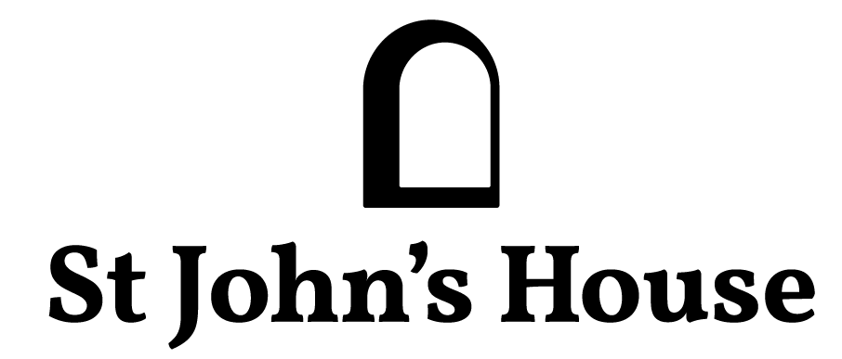

Newsletter Extra

St John’s House at Christmas

The house is decorated for Christmas with all manner of visual delights including a collection of nativity scenes. We have two more open days – Saturday December 2nd and Sunday December 10th.

We have tea and coffee available to keep out the cold and a 12 Days of Christmas trail for children.

Our current local artist, Timothy Lewis will be here with his art installation “Watching Paint Dry” and he’d love all our visitors to join in, pick up one of his brushes and add their contribution to the piece he is creating – come along and have a go!

Our shop has a selection of handmade Christmas decorations and a host of other interesting things which may make unusual presents.

A Victorian Christmas

On Friday December 1st at 7:30 pm – we welcome Debra John, the talented local actress giving us her version of a Victorian Lady’s tales of her Christmas.

Debra’s performances are completely absorbing as she really inhabits her character and leaves you feeling you were actually there. St John’s House is atmospheric at night with the candlelight creating interesting shadows and highlighting the 16th Century timber and stonework.

It’s just £10.50 per person, there are still tickets available through Eventbrite and we’ll be providing seasonal light refreshments to help the evening along.

St John’s House is a charity, our charity number is 1147340
Email: saintjohns@hotmail.co.uk
Website: https://stjohns-bridgend.org.uk
Facebook: St John’s House Bridgend
Address: 22 Newcastle Hill, Bridgend, CF31 4EY

