

**Newsletter** – May 2024

**St John’s House in May**

In April we were pleased to unveil the new International Women’s Day quilt, beautifully worked by the Cutting Edge textile group and to welcome the quilt to its new home here at St John’s House.

In our exhibition space we now have a display of items made by the Acme Vacuum Flask Co. on the Bridgend Trading Estate. As well as vacuum flasks they made a range of rather attractive vases and drinking sets.. Come along and see a small part of Bridgend’s recent history on display.

On **May 14th** from 11am to 2pm we are holding a plant sale in St John’s house, both garden and house plants. Entry is free.

The well-known local story teller, David Ambrose, is back with us on the eveningof **June 22nd**. He is presenting his programme of Midsummer Tales which promises to be every bit as enthralling as his previous performances in St John’s House. There will also be light refreshments provided in the interval. It promises to be an enjoyable evening. You can book your tickets **here**.

**St John’s House Survey**

We have been given a small grant to bring in a consultant to help us here in St John’s House He needs to know more about how people become aware of St John’s House and how they see it. He has devised a short survey for this and is offering a £50 shopping voucher to one lucky person who completes the survey. He will use the information to make recommendations to the Trustees. Please complete the survey which you can find **here**

**Dates for your diary**

**Next open days** Sunday 12th May 2024 11am-3pm

Saturday 25th May 2024 11am-3pm

Sunday 9th June 2024 11am-3pm

Saturday 29th June 2024 11am-3pm

**Next two quiz dates** Friday 17th May 2024 7.30pm

Friday 21st June 2024 7.30pm

**The Acme Vacuum Flask Company**

The Acme Vacuum Flask Company was a London firm based in Stepney, in the East End The firm was owned by Mr Alfred Jens Peter Boesen, who is likely to have been Danish, but was granted British citizenship in 1933. He was joined later by Bruno Ernst Kohn, originally from Nuremberg in Germany, who had lived in this country since the turn of the 20th century and had become a British citizen in 1905. Mr Kohn lived in Kingston on Thames but Mr Boesen, from 1948 to 1958, lived in Victoria Avenue in Porthcawl.

In 1947, the company set up a factory in Bridgend on the newly established trading estate, which had taken over the site of the war-time ordinance factory. They took over the Phoenix Works and employed around 100 people, making vacuum flasks. Later they branched out into to decorative items such as vases, water jug and glass sets and lampshades, apparently retailed through F W Woolworth stores.

Mr Kohn died in 1957 and the Acme vacuum flask company was taken over by Antiference Ltd. It was wound up in December 1965.

Mr Boesen died in 1994 at the age of 95.

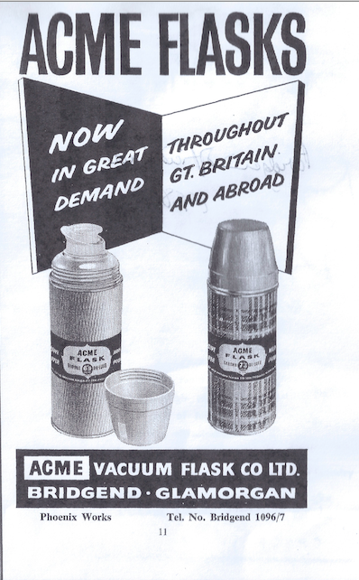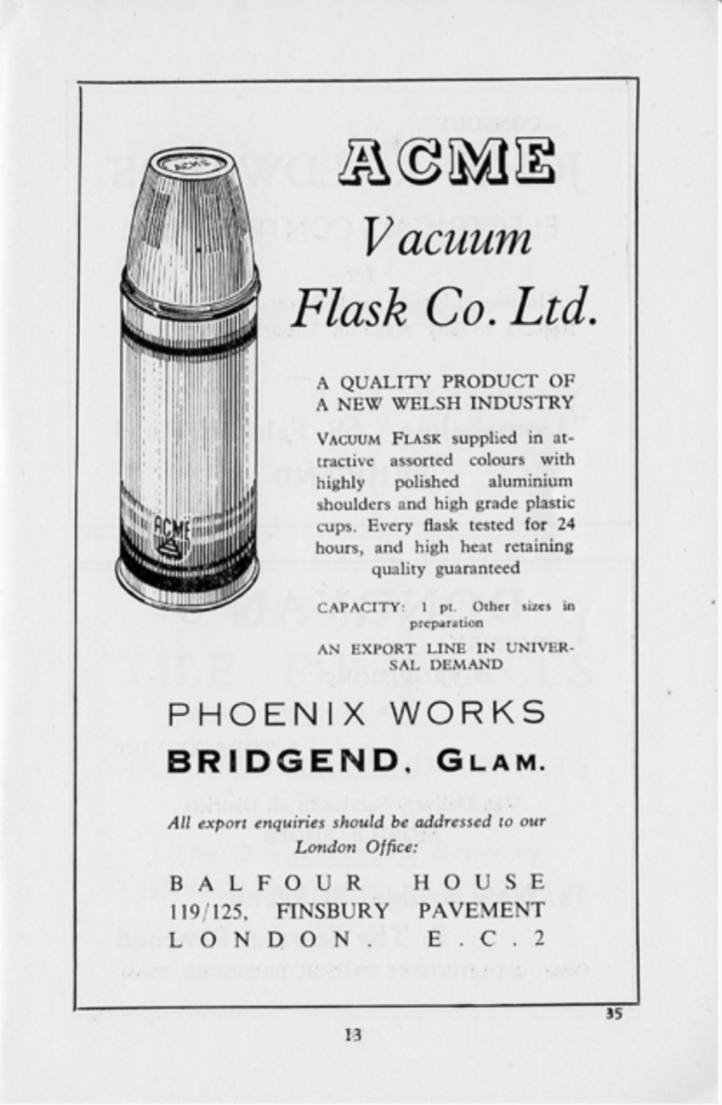

St John’s House is a charity, our charity number is 1147340

Email: [saintjohns@hotmail.co.uk](mailto:saintjohns@hotmail.co.uk)

Website: <https://stjohns-bridgend.org.uk>

Facebook: St John’s House Bridgend

Address: 22 Newcastle Hill, Bridgend, CF31 4EY