Newsletter – May 2023

St John’s House in May

We are continuing the Calan Mai decorations for the whole of May so look out for our blossom decorations, maypole and our Green Men.
There’s a Green Man trail for children with a small prize for completing the trail. On Saturday 27th May we will be having another plant sale here at St John’s House.
The May Quiz in aid of funds for St John’s will again be held in the friendly setting of the outdoor bowls club in Newbridge Fields on May19th.
Our Saturday Open Day on June 24th coincides with St John’s Day and the chance of celebrating our namesake is too good an opportunity to miss.
We hope to be able to make an exciting announcement about the future of the house then. The plan is to have live music and refreshments and we are probably going to use that Open Day to launch our new historical walks, These will start and end at St John’s House with tea and a Welsh cake to finish off.
It’s looking like a great year for St John’s House, so do come along and share it with us!

Dates for your diary

Next open days Sunday 14th May 2023 11am-3pm
Saturday 27th May 2023 11am-3pm
Sunday 11th June 2023 11am-3pm
Saturday 24th June 2023 11am-3pm

Next two quiz dates Friday 19th May 2023 7.30pm
Friday 16th June 2023 7.30pm

Dendrochronology

We are lucky, here at St John’s House, to now know that this house, when first built, dates from the early fifteen hundreds.
However, as we could find no written records of any kind relating to the construction of St John’s House, we had to find other means of establishing exactly when it was built. It is often said that if only walls could talk, think what they could tell us. In this case it as the roof beams that did the “talking”.
Dendrochronology, the science of tree ring dating, works by counting the growth rings in the timber but there is obviously a lot more to it than that . Each tree ring represents a year’s growth and varies according to the weather conditions in that period. Other trees of the same species, growing in the same area, will have the same shape and pattern of rings.
To make the comparison, samples are taken from timber which has remained in the same place since the house was built. An auger is used to drill through to the heartwood at the centre of the timber. This auger is hollow so, when it is withdrawn from the timber it contains a narrow core of wood from the centre to the outside of the beam with a pattern of stripes which represent the growth rings. Laboratories hold a database of samples from trees whose age is known and, using a process called crossdating, they match the sample against the database to give the date of felling. So we know that the timber for the beams was felled in 1511/1512 so the house is likely to have been built very soon afterwards. It’s a shame that the timber can’t tell us who built St John’s House!

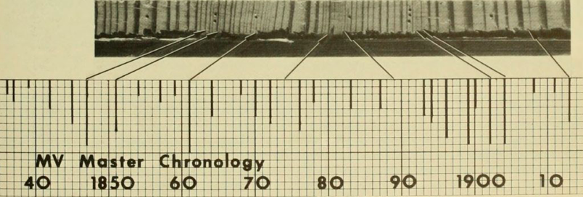

Here’s an impression of a sample.

Here at St John’s House we have all sorts of lovely items for sale.
Have a look in our shop and see what you can find
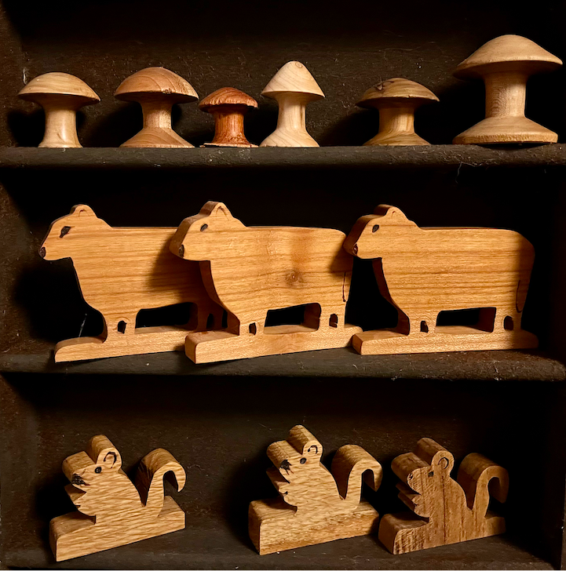
St John’s House is a charity, our charity number is 1147340
Email: saintjohns@hotmail.co.uk
Website: https://stjohns-bridgend.org.uk
Facebook: St John’s House Bridgend
Address: 22 Newcastle Hill, Bridgend, CF31 4EY

