

**Newsletter** – July 2024

**St John’s House in July**

2024 is already half gone but, despite the weather, it’s been a good year with more visitors this year than ever before. The Cutting Edge group’s International Womens Day quilt with its fascinating histories and intricately beautiful needlework continues to bring people in to admire the handiwork.

David Ambrose’s story-telling session went very well, we were all spellbound by the power of well-crafted, superbly delivered stories. Later in the year we have the return of Debra John with tales for Hallowe’en so look out for details of that. Debra is also with us for the open day on September 8th in her role as a Victorian parlour maid. At the end of September, the 28th and 29th, we welcome back our friends, the Bowmen of Gwent, with their period archery equipment and encyclopedic knowledge of historic archery. This is part of Ogwr History Month, together with many other heritage organisations in Bridgend County, celebrating Cadw’s Open Doors initiative.

In December we are holding Christmas wreath-making workshops so that’s another one to look out for.

In our exhibition space it is the final month of our display of glassware made by the Acme Vacuum Flask Co. on the Bridgend Trading Estate.

In our shop we have some very cute crocheted pot plants for sale, all fair trade, so you can give into temptation with an clear conscience!

**Dates for your diary**

**Next open days** Sunday 14th July 2024 11am-3pm

Saturday 27th July 2024 11am-3pm

Sunday 11th August 2024 11am-3pm

Saturday 31st August 2024 11am-3pm

**Next two quiz dates** Friday 19th July 2024 7.30pm

Friday 16th August 2024 7.30pm

**Welsh Dressers**

The Welsh dresser evolved over the centuries from a utilitarian set of shelves set above a work table holding eating and cooking utensils which you would have found in a kitchen at the time St John’s House was built. Over the centuries, in even the most modest Welsh homes, it had become an elaborate piece of furniture with open shelves set onto a set of cupboards where you would display the best china. This display almost always included anumber of lustre jugs, often in brown with blue designs. There were other lustreware items but jugs seemed to feature most prominently. The lustre decoration was particularly effective in catching and reflecting the light in dimly-lit rooms, glinting in the candlelight.

Here at St John’s House our Welsh dresser is kitted out, in the best tradition with the best china and we have quite a collection of lustre jugs to set it off to perfection.

Don’t forget that our shop has all sorts of traditional gifts and mementos of St John’s House including love spoons and our own range of stationery to remember us by. We also have an extensive seletion of secondhand books for sale so why not pop along and have a look at what we have on offer.

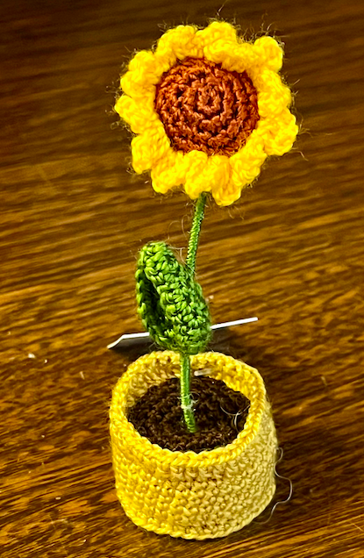 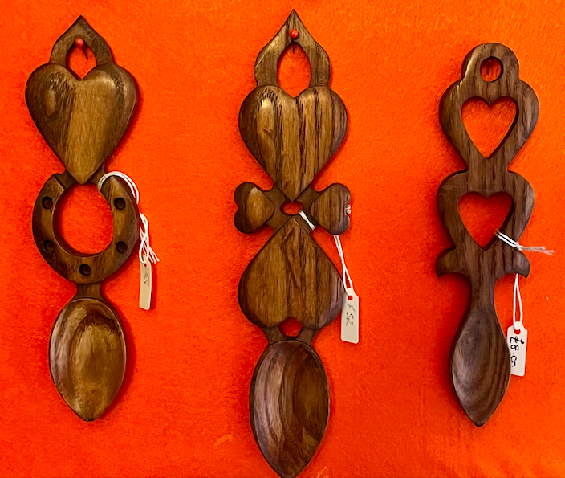 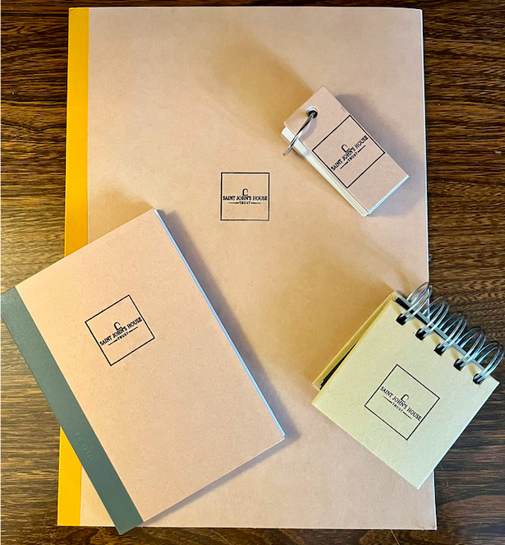

St John’s House is a charity, our charity number is 1147340

Email: [saintjohns@hotmail.co.uk](mailto:saintjohns@hotmail.co.uk)

Website: <https://stjohns-bridgend.org.uk>

Facebook: St John’s House Bridgend

Address: 22 Newcastle Hill, Bridgend, CF31 4EY