

**Newsletter** – January 2025

**St John’s House in January**

We’ve cleared away the Christmas trees and the tinsel and it’s full steam ahead for another year.

Our next couple of open days will celebrate Wales’ own St Dwynwen, whose day is 25/1 and, not to let anyone feel left out, St Valentine in February so it will be hearts all the way.

In February St John’s House will go live on Bloomberg Connects. This is an app for your mobile phone which acts as an online guide to places of cultural or historic interest. It is funded by the Bloomberg financial firm through their charitable arm, Bloomberg Philanthropies and their intention is to make cultural information free and available to all.

You can access it at any time to find out what’s available to see in St John’s House and you can also use it as an electronic guide when you visit St John’s House. You simply hold your phone to a QR code either at the door or on an item of interest and it takes you to the guide. There are a number of places in South Wales already on the app such as the Swansea Museum, The Glynn Vivian Art Gallery in Swansea, Cyfartha Castle Museum in Merthyr and Caldicot Castle in Gwent.

Our go-live date is 3rd of February so you should be able to find us on the Bloomberg Connects app from then and also use the QR codes when you visit St John’s House.

**Dates for your diary**

**Next open days** Sunday 12th January 2025 11am-3pm

Saturday 25th January 2025 11am-3pm

Sunday 9th February 2025 11am-3pm

Saturday 22nd February 2025 11am-3pm

**Next two quiz dates** Friday 17th January 2025 7.30pm

Friday 21st February 2025 7.30pm

**St Dwynwen’s Day 25th January**

St Dwynwen was one of 24 daughters of King Brychan Brychaenog of Brecon.

The details of her story vary but the essence is that she was in love with a

the Prince called Maelon Dafodrill, son of a neighbouring King but her father had already promised her in marriage to another. When Maelon asked for her hand, her father refused and Maelon had a tantrum. As a consequence of this he was turned into a block of ice. Dwynwen ran into a forest, appealed to God for help and cried herself to sleep. In a dream, an Angel appeared and

granted her three wishes. She used the first wish, generously, to thaw

out Maelon, for the second she asked that God watch over all lovers and the

third wish was that she should never marry. She became a nun and founded a

convent on Llanddwyn Island just off the coast of Anglesey where you can find the ruins of her church and a holy well attributed to her.

**St Valentine’s Day 14th February**

St Valentine was Roman bishop, martyred on February 14th AD 269 for

having tried to convert Emperor Claudius ll to Christianity.

Like St Dwynwen, details of his life and deeds which earned him

sainthood are sketchy but his connection to declarations of love

are based on the story that, having restored the sight of at least one young

girl, he sent her a note, just before his execution, signed “Your Valentine”

He has always been linked with the idea of courtly love.

Whichever saint you may favour and, why not go for both, we will be happy to welcome you to St John’s House to celebrate!

*Our shop has all sorts of traditional gifts and mementos of St John’s House including love spoons, wooden toys, jewellery and our own range of stationery. We also have an extensive selection of secondhand books for sale so why not pop in and fill your bookshelves ready for the cold winter nights*

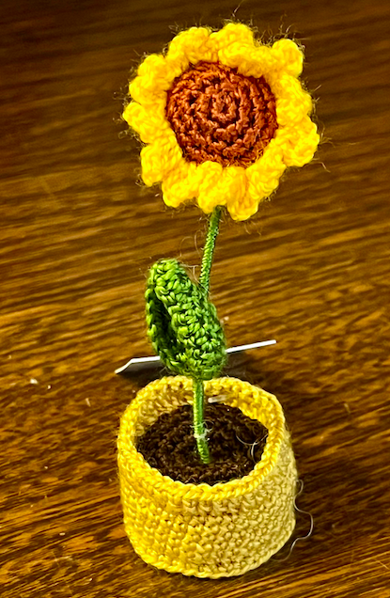 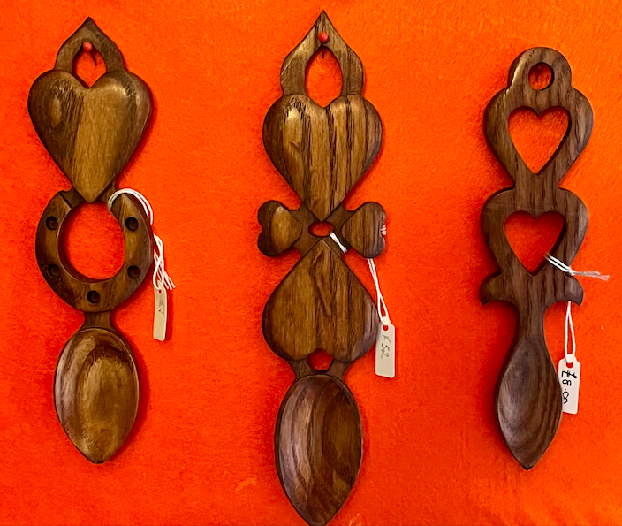 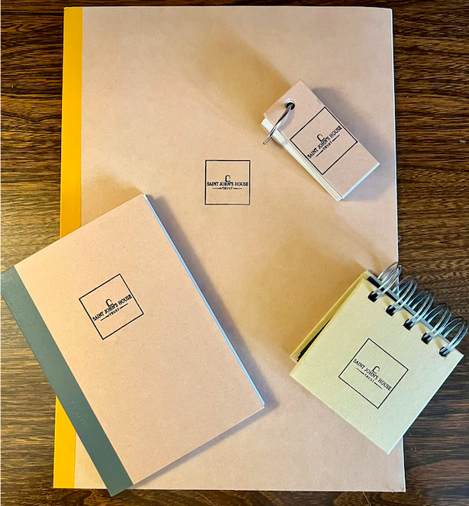

St John’s House is a charity, our charity number is 1147340

Email: [saintjohns@hotmail.co.uk](mailto:saintjohns@hotmail.co.uk)

Website: <https://stjohns-bridgend.org.uk>

Facebook: St John’s House Bridgend

Address: 22 Newcastle Hill, Bridgend, CF31 4EY