

**Newsletter** – February 2023

**St John’s House in February**

January’s Saturday Open Day celebrating St Dwynwen was one of our busiest and most successful, it was great to see so many people enjoying St John’s House!

For our February 11th Open Day we are celebrating St Valentine and on the Open Day of February 24th we will be looking forward to St David’s Day with a Dewi the Dragon trail for children and plenty of Welsh flags. In the Great Hall weare displaying a bust of Wil Ifan, the Welsh poet.

We also have a selection of lovespoons in our shop if you’re looking for a present for St Valentine’s day.

Our events folk are busy planning a series of interesting stuff for the year ahead. The first is on our April 14th Open Day when we welcome another striking quilt. This one celebrates inspirational women who have had an impact on Wales and celebrated International Women’s Day 2023. We are delighted for St John’s House to have been chosen as its permanent home.

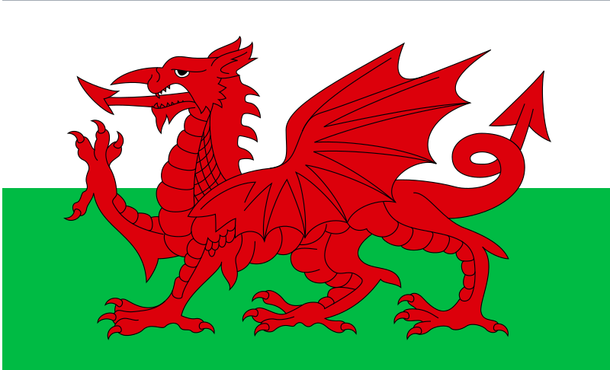 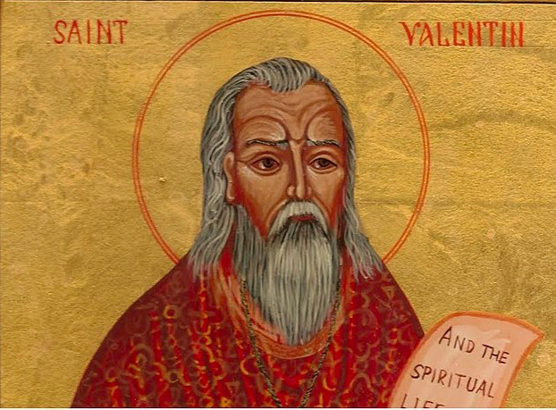

**Dates for your diary**

**Next open days** Sunday 11th February 2024 11am-3pm

Saturday 24th February 2024 11am-3pm

Sunday 10th March 2024 11am-3pm

Saturday 30th March 2024 11am-3pm

**Next two quiz dates** Friday 16th February 2024 7.30pm

Friday 15th March 2024 7.30pm

**Wil Ifan**

The celebrated Welsh poet known as Wil Ifan, whose actual name was William Evans, was born in Carmarthenshire on April 22nd 1883, the son of a Congregationalist minister. He went to school in Port Talbot and graduated from the University of Wales, Bangor and Mansfield College, Oxford, a college which catered largely for Congregationalist students. He was ordained in the English Congregationalist chapel in Dolgellau in 1906, where he took up his first ministry, met and married his wife, Nesta.

In 1909 he moved to Bridgend as the minister of the English Congregationalist church in Wyndham Street, where, with a brief period in the Richmond Road, Cardiff Congragationalist Church from 1917 to 1925, he served until retiring in 1949. He remained the minister emeritus until his death.

He won the crown for Pryddest (poetry in free verse) at the Eisteddfodau in Abergavenny(1913); Birkenhead (1917), where Hedd Wyn won the chair posthumously and Pwllheli(1925).

He was Archdruid of Wales in the Gorsedd of Bards from 1947 to 1950, including the 1948 National Eisteddfod held here in Bridgend.

As well as being an accomplished poet in both Welsh and English, he wrote a newspaper column in the Western Mail and was a broadcaster on reigious topics on the BBC.

He died on July 16th 1968 and was buried at Rhydymain in Merionthshire.

The English Congregationalist church in Wyndham Street is now the Phoenix night club.

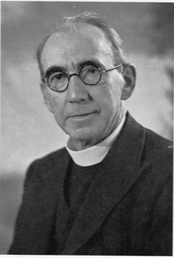

St John’s House is a charity, our charity number is 1147340

Email: [saintjohns@hotmail.co.uk](mailto:saintjohns@hotmail.co.uk)

Website: <https://stjohns-bridgend.org.uk>

Facebook: St John’s House Bridgend

Address: 22 Newcastle Hill, Bridgend, CF31 4EY