

**Newsletter** – December 2024

**St John’s House in December**

Christmas is upon us, the shortest day is within sight and it seems to be dark before you’ve finished lunch! Nevertheless, after this the days start to lengthen and a new year is upon us, with thoughts of renewal and the prospect of Spring.

St John’s House is decorated for Christmas. Our window sills inside are covered with greenery as was the tradition in Tudor times, signifying fertility, long life and continuity.

Christmas trees have been known since the time of Martin Luther but, in Britain they are generally regarded as a Victorian invention, introduced by Prince Albert but there are records of small trees being brought indoors and decorated for Christmas by George lll’s Queen, Charlotte of Mecklenburg-Strelitz, who was Queen Victoria’s grandmother and of German origin. So, to celebrate St John’s House’s Victorian heritage we have no fewer than three trees.

The solar in St John’s House, the room above the porch, is wholly the domain of children so the tree there is hung with cut out shapes to be coloured and decorated by children. There’s still room on the tree we welcome children to come along, try out our 12 days of Christmas trail, make a tree decoration, do some brass-rubbing, play a traditional game, help themselves to a free book or dress up in some of our very regal costumes.

We also have several new lines in the shop, including rather nice St John’s House Bic biro.

A very merry Christmas to you all!

**Dates for your diary**

**Next open days** Sunday 8th December 2024 11am–3pm

Saturday 14th December 2024 11am-3pm

Sunday 12th January 2025 11am-3pm

Saturday 25th January 2025 11am-3pm

**Next two quiz dates** Friday 13th December 2024 7.30pm

Friday 17th January 2025 7.30pm

Crib Scenes

Crib scenes have a long history dating from the early 4th century AD, initially featuring the Epiphany - the visit of the Three Kings. There are also images of the Christ child in a manger with animals, stressing his humanity rather than his divinity. There are reports of a life sized crib model in the church of Santa Maria Maggiore in Rome in the 11th century.

From then on large-scale models, often life-sized, appeared in Christian churches and wealthy homes. The reformation brought a backlash against what was seen as idolatry and protestant churches removed or destroyed their nativity scenes. Interestingly, where Christmas trees have always been associated with Protestanism, crib scenes are more closely associated with Catholicism Gradually they have again become a popular signifier of the Christmas season.

Traditionally crib scenes include the baby Jesus, Mary, Joseph, shepherds, an angel, an ox, an ass and three kings.

There is a traditional sequencing to the set up of the crib scene. The stable is put up on December 9th, the day after the feast of the Immaculate Conception, together with the animals. The Angel, Mary, Joseph and the shepherds are added on Christmas Eve with the baby Jesus placed in the scene on Christmas Day. The Three Kings should only appear at Epiphany, January 6th, although such rigorous timing tends to be ignored these days. The setting up of the crib is seen as symbolizing the coming of Christmas.

Crib scenes are found in Christian communities all over the world as you will see in our exhibition!

*Our shop has all sorts of traditional gifts and mementos of St John’s House including wooden crib scenes, love spoons, wooden toys, jewellery and our own range of stationery. We also have an extensive selection of secondhand books for sale so why not pop in and fill your bookshelves ready for the Christmas holiday*

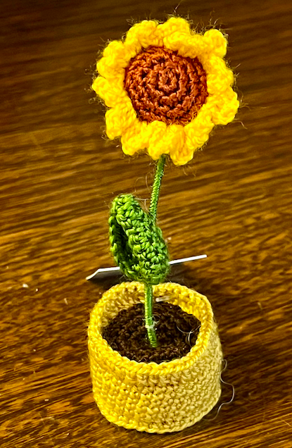 

St John’s House is a charity, our charity number is 1147340

Email: [saintjohns@hotmail.co.uk](mailto:saintjohns@hotmail.co.uk)

Website: <https://stjohns-bridgend.org.uk>

Facebook: St John’s House Bridgend

Address: 22 Newcastle Hill, Bridgend, CF31 4EY