Newsletter – December 22

St John’s House in December

Our first Christmas open day went well and now it’s a case of freshening the displays, replacing the wilted greenery and gearing ourselves up for the next open day on the 10th of December. The bay leaves, dried herbs and yew foliage all smelled wonderful. We’re looking forward to that day as Call of the Wild, the folk group who performed here in September, have agreed to come along and play their music again in the house. Our next quiz in aid of St John’s will have a Christmas theme and we will again be enjoying the hospitality of the outdoor bowls club in Newbridge Fields.

Christmas, in the Tudor period, was a time for rest and recuperation as well as celebration. During Advent, indeed up to Christmas Eve, people fasted and then marked the arrival of Christmas with feasting and merry-making. There really were 12 days of Christmas and it was marked by hospitality and good will to all. Christmas trees were a Victorian innovation but Tudor folk decorated their house with greenery such as yew, holly, ivy, laurel and mistletoe.
In St John’s House we look back to that period in the way we decorate the house with greenery of all sorts.
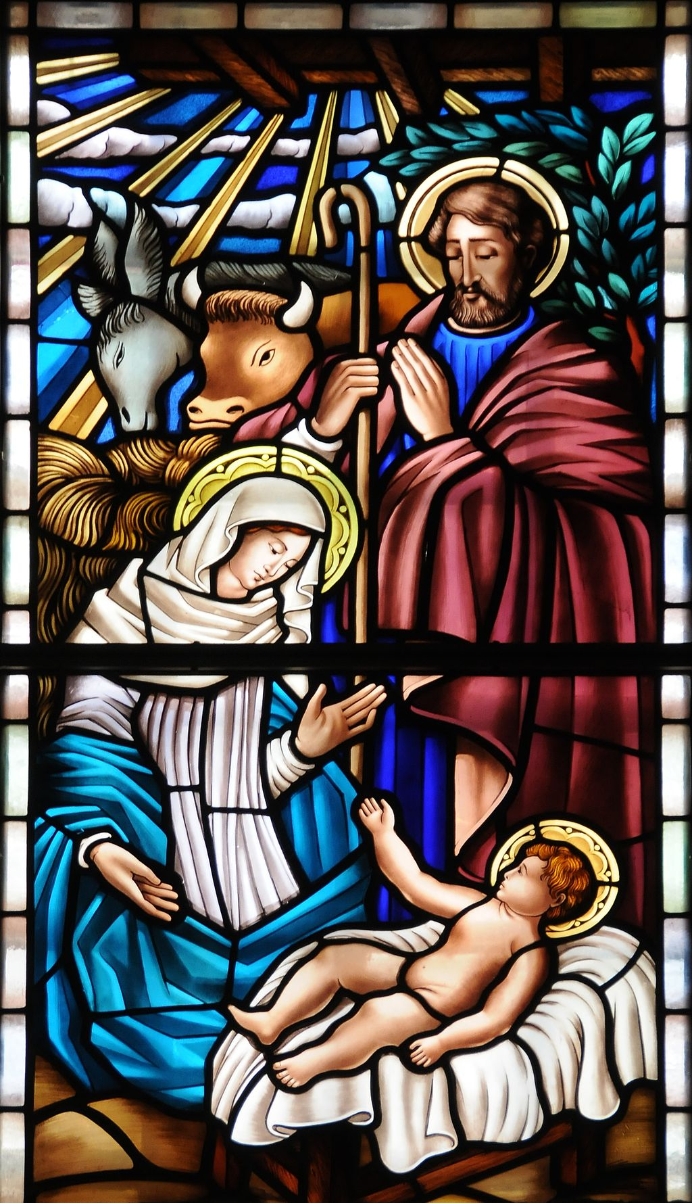

Dates for your diary

Next two open days Saturday 10th December 11am-3pm
Saturday 29th January 2023 11am-3pm

Next two quiz dates Friday 16th December 7.30pm
Friday 20th January 2023 7.30pm

Plygain
Here in Wales we have our own set of very distinctive and sometimes rather baffling Christmas traditions, all of which seem to involve singing and eating. There is the Mari Llwyd, a group of folk going from door to door with an ornamented horse’s skull, singing traditional songs until the door was opened to let them in so they could be offered food and drink.
Then there is Plygain, a sort of anarchic, yet pious, community carol service.
It is thought to be a Protestant follow-on from the Catholic midnight mass. Originally held at 3am on Christmas morning, over the years it slipped forward to about 6am. The worshippers usually brought their own candles and the Plygain would start with a short church service, a brief sermon and then family groups would come forward and start singing traditional Welsh carols. These would be followed by others, singing other carols – they were never repeated in the same service – in a spontaneous way until the final carol-y-swper, or supper carol, after which the congregation would move to the vestry for a meal. The carols covered not only Jesus’ birth but his life, crucifixion and resurrection. The tradition survived the rise of Non-conformist chapels in the 19th century but persists these days only oin a few rural areas, mostly in North East Wales. Nevertheless, in 2021, during lockdown, the Plygain went virtual with a national Plygain service held live on Facebook.

Here at St John’s House we have lots of handcrafted items, perfect for Christmas gifts.

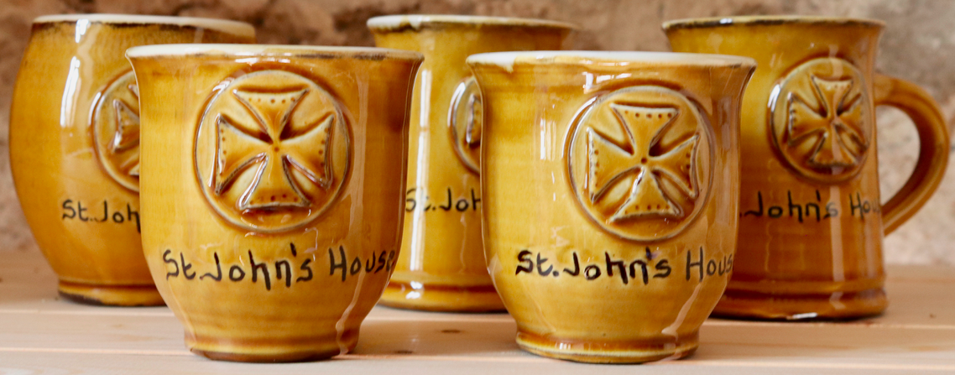
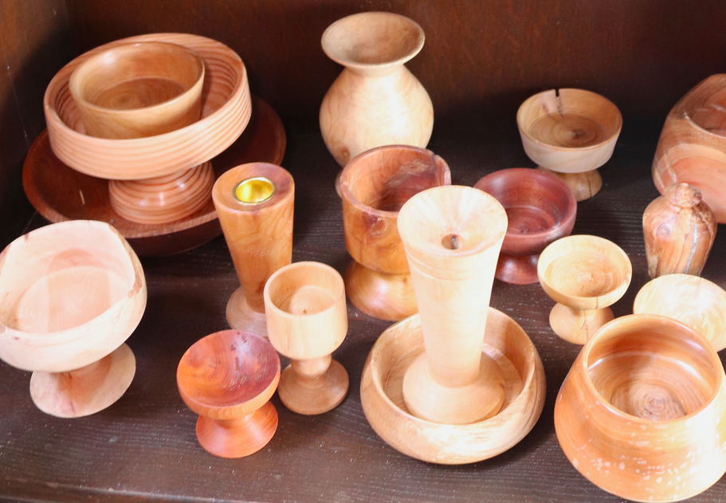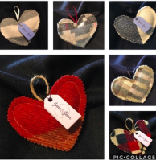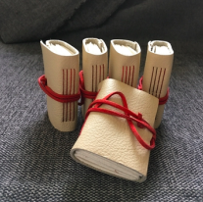
Some of the hand crafted items from our shop

St John’s House is a charity, our charity number is 1147340
Email: saintjohns@hotmail.co.uk
Website: https://stjohns-bridgend.org.uk
Facebook: St John’s House Bridgend
Address: 22 Newcastle Hill, Bridgend, CF31 4EY

