

**Newsletter** – April 2024

**St John’s House in April**

March’s Easter Open Days were popular with lots of new visitors as well as many old friends returning to the house. The children enjoyed the Easter trail and we’ll be continuing the Easter theme through to our 14th April Open Day.

This is the last month for Tim, our current resident artist who is delighted at the quality and variety of the images visitors have painted on his bench, so this is your last chance to add your input to a piece of community art.

We have a programme of events for the rest of the year, starting with the launch of the International Women’s Day quilt on April 14th. Members of the Cutting Edge Textile Group who made the quilt will be in the house for the event and there will be cake!

On May 14th from 11am to 2pm we are holding a plant sale in St John’s house, both garden and house plants. Entry is free.

We have a number of events which will need to be booked

On June 22nd in the evening we have David Ambrose, the story-teller, with Midsummer Tales.

On October 25th again in the evening we have actress Debra John with Ghostly Tales.

On December 7th during the day we have Wreath-Making Workshops.

In December we are also planning tours of the house by candlelight, complete with mulled wine and mince pies.

We will notify you as soon as booking for these events is open.

**Dates for your diary**

**Next open days** Sunday 14th April 2024 11am-3pm

Saturday 27th April 2024 11am-3pm

Sunday 12th May 2024 11am-3pm

Saturday 25th May 2024 11am-3pm

**Next two quiz dates** Friday 19th April 2024 7.30pm

Friday 17th May 2024 7.30pm

**St John’s House Survey**

We have been given a small grant to bring in a consultant to help us move onto the next chapter in the story of St John’s House – making the House more accessible to all. As part of this process we need to know more about how people become aware of St John’s House and how they see it. He has devised a short survey for this and is offering a £50 shopping voucher to one lucky person who completes the survey. All of the results will go direct to the consultant and he will use the information to make recommendations to the Trustees. Please complete the survey which you can find here

**Quilting**

Quilting is thought to have started around the time of the Crusades when ladies would make padded garments for the knights to wear under their armour as protection and to keep out the cold. Gradually this functional process took on a more decorative purpose and quilts were produced as bedding and as wall hangings. In a number of cultures women would produce a quilt as part of their dowry, demonstarting their dexterity with a needle. There is a strong tradition of quilting in America where enslaved women would make quilts of whatever material they could find to supplement their meagre bedding.

The International Women’s Day Quilt was made by the Cutting Edge Textile Group of Ystradowen to celebrate the achievements of women who have had an impact on Wales. It has been shown in a number of venues around South Wales and we are proud to have been chosen to house it here along with the Bridgend Quilt.

Come along on April 14th and welcome IWD quilt to its new home.

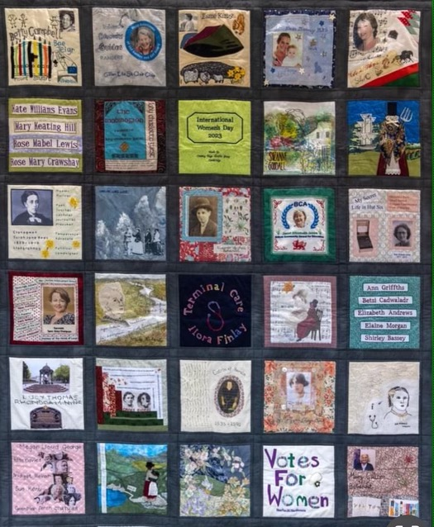

The international Women’s Day Quilt

St John’s House is a charity, our charity number is 1147340

Email: [saintjohns@hotmail.co.uk](mailto:saintjohns@hotmail.co.uk)

Website: <https://stjohns-bridgend.org.uk>

Facebook: St John’s House Bridgend

Address: 22 Newcastle Hill, Bridgend, CF31 4EY